고주파시스템공학 중간고사 문제 (2024-4-26, 13:00-13:50)
학번 ( ), 성명 ( ), 이동전화번호( ), PIN ( )
PIN = abcd: 휴대전화 끝 4 자리 (예: 010-8028-3194, a = 3, b = 1, c = 9, d = 4), 단 각 숫자가 0인 경우 순차적으로 1, 2, 3, 4로 대체 (예: 010-1234-0097인 경우 a = 1, b = 2, c = 9, d = 7)
배점: 소문제당 10점, (주의) 뒷면에도 문제 있음.

1. Given R, L, G, C of a transmission line, write down 1) an equation for the complex propagation constant and 2) an equation for the complex characteristic impedance.

2. In a transmission line, an incident wave A, reflected wave B, a complex propagatioin constant γ, write down
1) an equation for the voltage at location z on the transmission line and 2) an equation for the current at location z on the transmission line.

3. A load Z_{L} at z = 0 is connected with a tranmision line of length l with Z₀ and β. Given, Z_{L} = 10(d - jc) Ω, Z₀ = 10a Ω, l = 0.2 wavelength (tranmssion line length), find at z = −l, 1) the load reflection coefficient Γ_{L}, 2) the input reflection coefficient Γ(−l), 3) the input impedance Z(−l) (Ω), and 4) the power P_{L} delivered to the load when a power of P_{i} of 1 watt is incident on the transmissio line at z = −l.
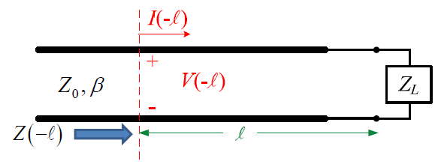

4. Write a Python code for Problem 3.
Input data: Z_{L}(complex), Z₀, β, l, P_{i}
Output data: Γ_{L}, Γ(−l), Z(−l), P_{L}

5. For a coaxial cable with the radius of the center conductor r₁ = a mm, the radius of the outer conductor r₂ = a+5b mm, the dielectric constant of the material between the inner and outer conductors ε_{r} = c, the relative permittivity of the material between the innder and outer conductos μ_{r} = d, find 1) the inductance per unit lenght L, 2) the capacitance per unit length C, and 3) the characteristic impedance Z₀.
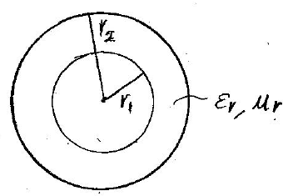

6. Write a Python code for Problem 5.
Input data: r₁, r₂, ε_{r}, μ_{r}
Output data: L, C, Z₀

7. With Z₀ = 10d Ω, 1) draw R = 10a Ω curve and X = −10b Ω curve on the impedance Smith chart, and 2) draw G = 1/(10c) S and B = 1/(10a) S curve on the admittance Smith chart.

8. In the figure below, given Z₀ = 10d Ω, Z_{in} = 100a Ω, Γ_{L}: magnitude = c/10, phase = 20b degrees, find 1) the minimum value of l in terms of the wavelength on the transmission line, 2) the input impedance Z₁ in the figure, and 3 Z_{T}. (Hint) Determine l such that Γ_{L} becomes a real value (imaginary part = 0) and then use the quarter-wave transformer.
